ANGELINE MORRISON
"A ballad maker for our time" - ArtsDesk.com
Angeline Morrison is a singer, multi-instrumentalist and songwriter who explores traditional song with a deep love, respect and curiosity. Angeline mostly makes music in the genres of wyrd folk and psych folk, her work infused with elements of soul music, literature, ‘60s beat pop sounds, folklore, myth and the supernatural. With a feral approach, a handmade sonic aesthetic and a belief in the importance of tenderness, Angeline’s original compositions and re-stitchings of traditional songs focus on storytelling and the small things that often go unnoticed. Sounds like solitude, memory, nostalgia, a rainy walk amongst trees. You can also hear Angeline as part of alt-folk duo We Are Muffy with Nick Duffy (of The Lilac Time), and psych-folk duo Rowan : Morrison with The Rowan Amber Mill.
Angeline made her television debut on ‘Later…with Jools Holland’ in October 2022, and The Guardian published a major interview.
Watch Later with Jools Holland performance
Read Guardian Interview
In July 2022, Angeline was announced as the fourth winner of the prestigious Christian Raphael Prize at Cambridge Folk Festival, which generously supports the development of emerging talent in the folk genre.
The Sorrow Songs: Folk Songs of Black British Experience (released October 2022, Topic Records) is a work of re-storying. The historic Black presence in the UK dates back to at least Roman times, yet is often hidden, forgotten or unacknowledged.

The populations of enslaved African people and their descendants in the USA have their bodies of folk song, which are vitally important for containing histories, expressing feelings, giving voice and claiming presence… but the Black ancestors of the UK have no equivalent body of song. The Sorrow Songs begins to address this.

It is a gift to the forgotten Black ancestors of these islands, and to the folk community here today. The album uses history and imagination to tell stories of UK Black ancestors in the sonic style of UK traditional and folk music.

The Sorrow Songs: Folk Songs of Black British Experience
Topic Records 2022
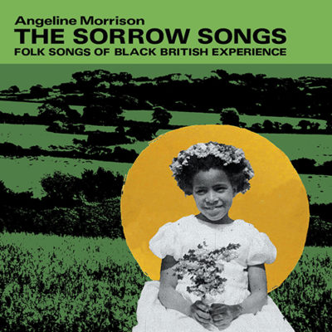
Angeline’s debut for Topic Records, it has been described as “a gift and landmark folk album,” by Folkradio.co.uk.
The stellar line-up of musicians on this album includes Cohen Braithwaite-Kilcoyne (anglo concertina, melodeon, vocals), Clarke Camilleri (guitar, banjo, vocals), Hamilton Gross (violin, vocals), Rosie Crow (piano, vocals), Alex Neilson (drums, vocals), Eliza Carthy (violin, fiddlesticks, vocals), Angeline Morrison (vocals, autoharp, double bass) and features Martin Carthy on the album’s closing track, ‘Slave No More.'
Produced by Eliza Carthy and featuring some of her beautiful, soaring string arrangements, The Sorrow Songs was recorded in Cornwall at Cube Studios and is a work of what Angeline calls ‘re-storying’: “The traditional songs of the UK are rich with storytelling, and you can find songs with examples of almost any kind of situation or person you can think of. But whilst people of the African diaspora have been present in these islands since at least Roman times, their histories are little known – and these histories don’t tend to appear in the folk songs of these islands.”
Angeline began to wonder if she could discover more about the lives of these ordinary and extraordinary Black ancestors, and create an album of songs in the sonic style of UK folk and traditional music, in the hope that this silent space could then begin to be filled with stories. With the help of Arts Council National Lottery funding, Angeline began what became a year of research into this neglected area of Black British history. The Sorrow Songs: Folk Songs of Black British Experience is the result.
Released to commemorate Black History Month, this powerful record is intended to honour these Black ancestors who lived in these islands, and to act as a gift to the folk community.
Angeline tells, “What I would really love is for people to want to sing these songs. I wrote each song with a chorus or refrain that I hope will be singable, so that people might want to sing them in folk clubs, and in doing so these stories will continue to be re-told in song.”
PRESS FOR THE SORROW SONGS
“Morrison’s courage in reconstructing folk repertoire is truly revolutionary. A groundbreaking album.” – New Internationalist Magazine (5 stars)
“The Sorrow Songs is a ground-breaking album; the music is excellent throughout, beautifully enhanced by the album’s exemplary artwork and packaging.” – Folk Radio
“Angeline Morrison paves the way and offers an authentic, brave folk voice of black British experience. In doing so, she presents us with a collection of songs that feel incredibly overdue. Long may they be sung out and loud.” – Tradfolk.co
“An important, essential folk album which casts light on the hidden history of black people in these sceptred /blighted isles.” – Americana-UK (9/10)
"Unequivocally one of the finest, and most important folk albums of this, or indeed, any year, beautifully crafted, performed and packaged, 'The Sorrow Songs' turns a long overdue spotlight on the country's forgotten stories and forgotten people, reclaiming their part in the UK folk tradition and history, and touching the deepest fibre of those who hear them". Folking.com

THE BROWN GIRL AND OTHER FOLK SONGS
(Independent release May 2022)
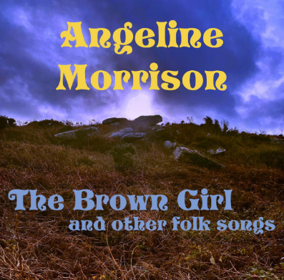
Angeline describes this album as ‘A collection of 10 traditional songs, chosen with love and care. The title track has been a talisman to me… it allowed me to dream people of colour into the songs of these islands, long before I knew about the fact of our historic presence here. The arrangements include multiple vocals, some drones, and as much space and light as possible.’
‘Abundant with meaning and feeling…masters the precision of storytelling, as well as its poetry… abundant with meaning and feeling’ – The Guardian, 4/5 stars. Guardian Folk Album of the month May 2022
‘Deft and accomplished’ - Rock n’ Reel, 5/5
‘One of those rare records that feels perfectly weighted, entirely free of anything extraneous… the whole thing feels lighter than air’ - Folk Radio UK
‘Bewitching and otherworldly… Morrison’s voice is eerily confiding, strangely present, insistent even at its quietest’ - Folk Radio UK
‘Has the hushed intensity of a seance, as if she’s channeling the spirits of the dead’ - Ele-King Magazine, Japan
‘A hypnotic performance’ - TradFolk.co
‘Morrison has stunning control over the emotional depths of these songs. Her musicianship is equally impressive.’ - Folk Radio UK

LINKS
Angeline’s website
YouTube
Topic Records
Facebook Twitter Instagram

CONTACT
Label Enquiries:
Topic Records
topic@propermusicgroup.com
www.topicrecords.co.uk

Press:
Jo Donnelly
jo.donnelly@propermusicgroup.com
​
Radio & TV:
Richard Wootton
richard@rwpublicity.com

Bookings and enquiries:
Claire Patterson
www.goodhonestmusic.com
+44 (0) 7872 075626
claire@goodhonestmusic.com
