JAMES DELARRE & SAUL ROSE

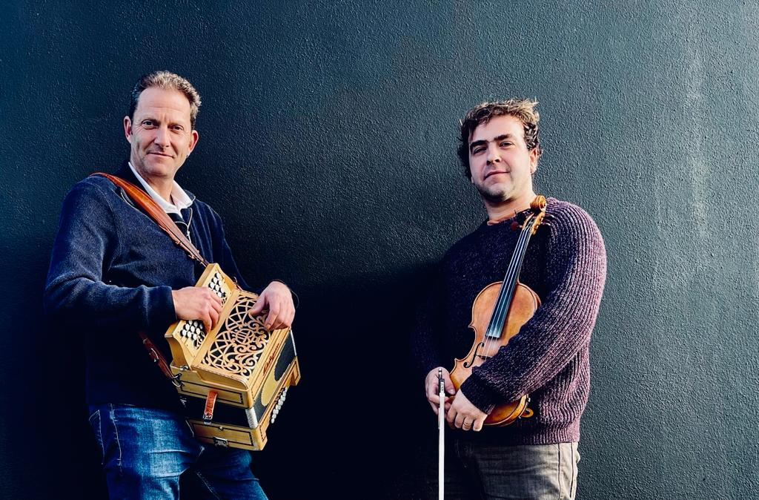

‘Masters of their craft. This duo is just brilliant’
FATEA Records

'Outstanding musicianship, James and Saul performed a perfectly balanced mix of tunes and songs'
Songlines

'Sheer joy of music making oozes through every track'
Living Tradition

With the timeless combination of fiddle and box, James and Saul have been making music together for a long time now and re-launch their live act after time focusing energies on their young families. Born out of friendship, the duo intertwine seamlessly; dancing around the tunes between the notes, finding space and air breathing life into the music they create together.
James Delarre
(Fiddle)
A veteran and founding member of the critically acclaimed Topette!!, Mawkin, and Mawkin:Causley, James Delarre has established himself as a stalwart of the English traditional music scene. As a fiddle player he is in high demand and has worked with some of the country’s top musicians and groups including, Eliza Carthy, Bombay Bicycle Club, Jim Moray, Jim Causley, Saul Rose, appearances with Bellowhead and Jools Holland as well as work as a musician on Tv and film. His filmography includes Peaky Blinders, Far from the Madding Crowd, Tulip Fever and My Cousin Rachel, to name but a few.

Saul Rose
(Vocals & Melodeon)
Saul Rose is a renowned English folk melodeon player and singer. A long-time member of Waterson:Carthy, winning two BBC Radio 2 Folk Awards with ‘Broken Ground’ and forming a duo with Eliza Carthy. Double album ‘Red Rice’ was nominated for the Mercury Music Prize in 1998. Saul played on numerous albums, including Jackie Oates’ ‘Hyperboreans’, Norma Waterson and Eliza Carthy’s album ‘The Gift’ and soundtracks for the films ‘Morris - A Life With Bells On’ and ‘Far From The Madding Crowd’. Nominated for the Musician of The Year award in the 2010 BBC Folk Awards, during 2011 he took the part of Songman in West End play War Horse. Now part of band Whapweasel and a duo with Maclaine Colsten, Saul was also a member of Faustus and a founder member of Eliza Carthy & The Wayward Band.

Press reviews for CABIN FEVER (2014)

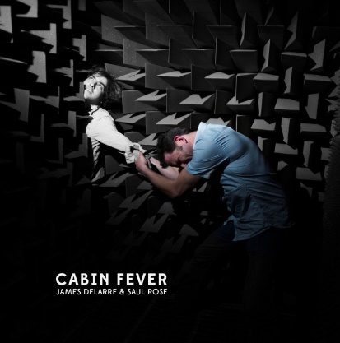

Living Tradition: ‘Well done to James and Saul for a smashing debut. James Declare and Saul Rose have been friends since they met at Sidmouth in 2007 and played in Morris Offspring. Now they’ve found time to pool their experience in the English tradition and come together as a duo for a debut album full of great tunes. James, on fiddle, is the driving force behind Mawkin with his guitarist brother David. Saul, on melodeon, is well known for his work with Waterson:Carthy, Faustus and Whapweasel. No other instruments and no guests, so this 48-minute album is highly focused and should please the purists. Their interplay is tight and intricate, sometimes fizzy, sometimes lyrical.’ (Living Tradition)

FATEA Records: ‘This duo is just brilliant. James and Saul are both masters of their craft and both have such a wealth of experience from their previous works that for them to come together for 'Cabin Fever' is great to see. Considering they only use the two instruments, fiddle and melodeon, they have managed to hit a good range of different arrangements that show off how much variety the pair is capable of. They really do give you the full range from emotional vocal ballads such as 'Swansea Town' and 'Lord Marlborough' to fast paced dance tunes like 'Frida's' and 'Sauteur Lapin/ France'. Even with slower paced tunes like 'Bell Towers/ The Orange in Blossom' you can see the care and attention taken in the arrangement and the playing itself. You can certainly see influences of Faustus (Saul) and Mawkin (James) in the music.’

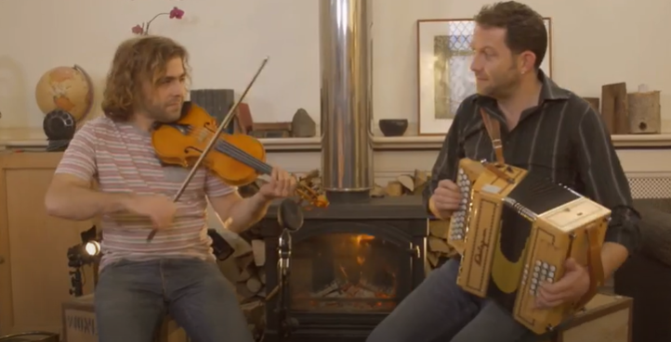
INTERNET LINKS
LinkTree: https://linktr.ee/jamesdelarresaulrose
Bandcamp: https://saulrosejamesdelarre.bandcamp.com/album/cabin-fever
YouTube: https://www.youtube.com/watch?v=vLhV24riYLs
Facebook: https://www.facebook.com/JamesDelarreAndSaulRose
CONTACT
Claire Patterson
www.goodhonestmusic.com
07872 075626 claire.s.patterson@outlook.com

