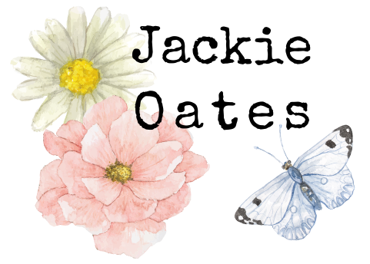

Information Pack

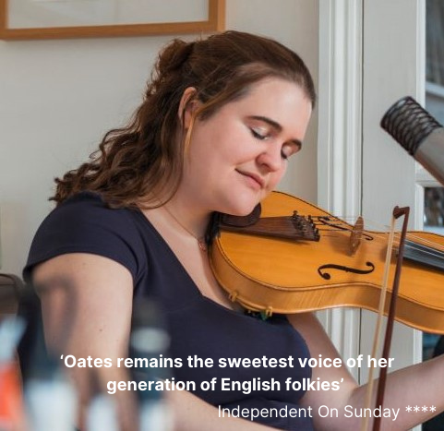

BIOGRAPHY
Jackie Oates is an English Folk Musician, Singer, Performer and Educator. Jackie lives in Oxfordshire with her young family.
After 17 years and seven solo albums Jackie Oates is a central figure in the accomplished, informed and stylistically individual English traditional music scene that began in the early 2000s and continues to thrive. Regarded as one of the country’s best loved folk performers, Jackie’s current focus is on collaborating with a diverse array of artists and commissions.
Jackie continues to perform concerts and make the solo records that regularly rack up glowing broadsheet reviews, and in addition of late, is focused on her work as a collaborator and contributor; finding new and surprising artistic corners to illuminate with her voice, research and musicianship.
Following the death of her much-loved dad five days after the birth of her first child, Jackie’s 2018 album ‘The Joy Of Living’ reached beyond the past lives in folk song to the lived experience of all of us. The Guardian called it “utterly gorgeous… moving, depth-filled.” Since then, Jackie has released classic covers with Scritti Politti’s Rhodri Marsden, researched pagan Bath for the mavericks at Lush cosmetics, been Artist In Residence at the Twitter-famous Museum of English Rural Life, lent her voice and musicianship to CBeebies’ Nick Cope’s Popcast, and begun an ongoing mixed media work about the history of lace telling.
2020 saw the release of an entirely handmade (right down to the sleeves) duo album with John Spiers, called ‘Needle Pin, Needle Pin’ that features some of the songs from Lace Tellings, Jackie’s radio ballad that tells the story behind the lives of the girls who lived and worked in the lace making areas of Southern England, through spoken word, songs and music.
Jackie Oates continues to bring elements of the English folk tradition to new people and places; in turn bringing a much-needed calm and joy to those who hear it.

MOST RECENT REVIEWS & RECORDINGS

Needle Pin, Needle Pin (2020) Jackie Oates & John Spiers
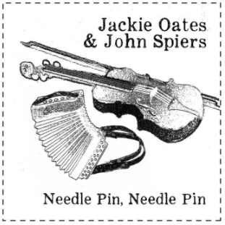 | - ‘It’s a treat to listen to, with joyful pieces like Congleton Bear (telling an unusual story from the Cheshire town) and a brandy-based pair of slip jigs particularly full of sunshine. Oates and Spiers are a fine match, the tunes elegantly paced and played, while Oates remains one of our finest singers’. - Mark Dishman, Folk Witness  - ‘Needle Pin, Needle Pin packs a great amount of variety into its 36 minutes, with the three musicians bringing the source material to life, in an unflashy yet well crafted manner. The result is a highly listenable collection of music that belongs on present day folk fans’ CD players as much as it does in a museum’. - Nick Hart, Bright Young Folk

The Joy of Living (2018)
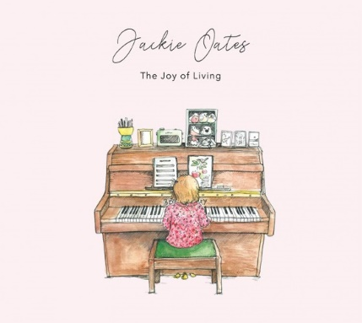 | - ‘An intensely personal folk gem….a moving, depth-filled album. Oates should be deeply proud of it.’ The Guardian **** 4 stars  - ‘A personal, affecting collection.’ The Observer **** 4 stars  - ‘A compelling, spirited, emotional rollercoaster of an album.’ Folk Radio  - ‘The soaring purity of Oates’s vocals washes through the songs leaving them like clean streets after a bout of rain.’ The Arts Desk

Wings (2016) Jackie Oates & Megan Henwood
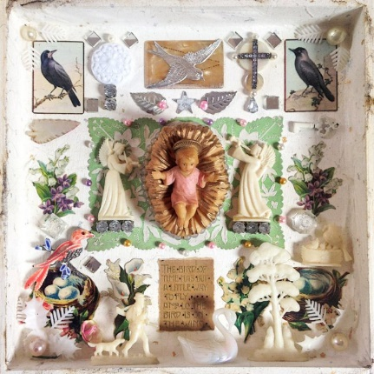 | ‘Jackie and Megan are supported on the EP by Pete Thomas on Double Bass and the whole thing comes together quite beautifully. “What’s The Use Of Wings” written by Brian Bedford is quite simply a stunning piece of folk music that sends shivers up my spine.’ - FATEA

CATERING RIDER & OTHER REQUIREMENTS

Please provide a private room with access to fresh water and tea/coffee, plus a hot meal for Jackie and band members or alternatively buyout of £10 per person. Plastic-free food and drink containers are preferred if possible please.

Jackie and band members may like to stay overnight (hosted or hotel) if the event is a long way from home. Jackie lives in Oxfordshire. This will be discussed as part of the booking agreement.

TECHNICAL SPECIFICATION

- Jackie Oates Duo
Jackie
Lead vocals, violin, shruti
Voc mic
Inst mic
XLR
+48 V
Mike
Keyboards, guitar, accordion,
vocals
Voc mic
DI x 4
No. | Instrument | Suggested mic | Notes
1 | Violins/violas | XLR line with +48V Phantom | To clip on mic (supplied)
2 | Shruti | C451/KM184 | On short stand
3 | Guitar | DI
4 | Keys L | DI
5 | Keys R | DI
6 | Accordion | DI | L/R sides mix to mono supplied.
7 | Jackie (lead) vocal | SM58 or equiv.
8 | Mike vocal | SM58 or equiv.

We would appreciate a 2-way monitor mix if possible – thanks.

TECHNICAL SPECIFICATION

- Jackie Oates + Band

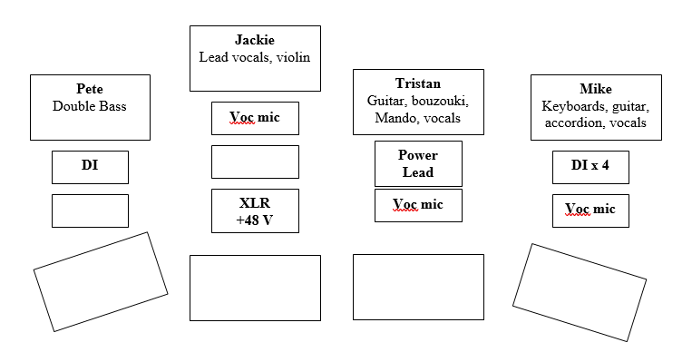
No. | Instrument | Suggested mic | Notes
1 | Double bass 1 | DI
2 | Violins/violas | XLR line with +48V Phantom | To clip on mic (supplied)
3 | Guitar/bouzouki | Power Socket/ Extension Lead | A/B switched on stage
4 | Guitar | DI
5 | Keys L | DI
6 | Keys R | DI
7 | Accordion | DI | L/R sides mix to mono supplied.
8 | Jackie (lead) vocal | SM58 or equiv.
9 | Tristan vocal | SM58 or equiv.
10 | Mike vocal | SM58 or equiv.

We would appreciate a 4-way monitor mix if possible – thanks.

INTERNET LINKS

Official website www.jackieoates.co.uk
www.facebook.com/jackieoatesmusic
https://twitter.com/jackieoates
https://www.instagram.com/jackieoates83
https://www.youtube.com/channel/UCgr1kjLoCXR2Zk5_TKyzqDw

CONTACT
Claire Patterson
Booking Agent
+44 (0) 7872 075626
claire.s.patterson@outlook.com
www.goodhonestmusic.com
Good Honest Music is a UK-based folk & roots music booking agency representing: Jackie Oates | Faustus | Belshazzar’s Feast | Benji Kirkpatrick & The Excess | Jon Wilks | Jackie Oates & John Spiers | Paul Sartin (solo) | Benji Kirkpatrick (solo)

