Information Pack

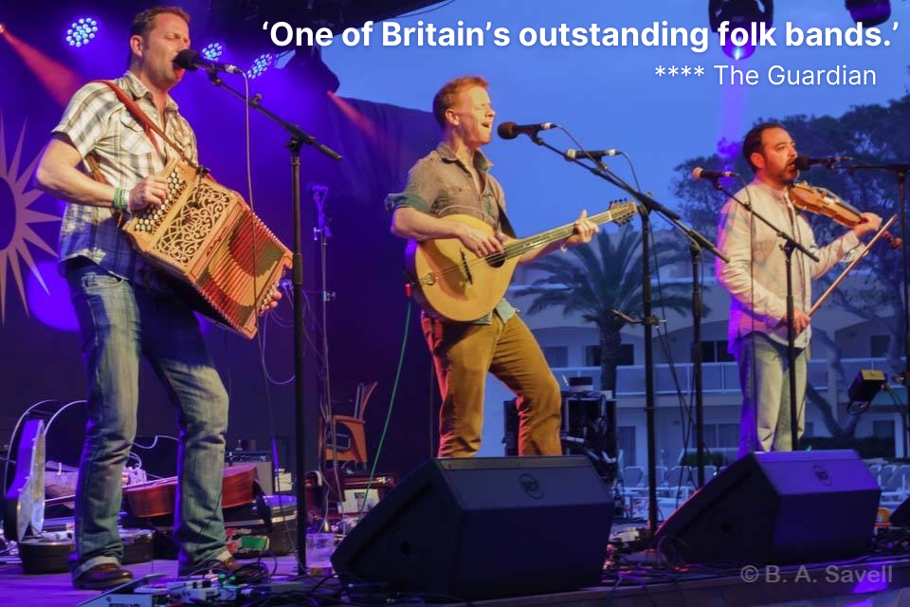

BIOGRAPHY

‘So stunning live’ says Tom Robinson (BBC Radio 6 Music), Faustus are known for captivating audiences with their sheer room-shaking power, vocal precision and instrumental mastery. Put simply, the band has complete command on stage and in the studio. Their live act is recognised worldwide; 2020 will see the band performing at venues in Australia and New Zealand, as well as touring throughout the UK.
Playing music for our times, Faustus take traditional English music, rip it up, put it together again and move it on. A vigorous rhythmic impetus and rock/prog rock influence propels the sound into the here and now and a range of instruments deployed in unconventional ways gives a unique texture, depth and variety to the band’s sound.
Driving rhythms on bouzouki and guitar are reinforced by the melodeon, fiddle, oboe and cor anglais, creating arrangements that are intriguing and subtle, boisterous or punchy. ‘Faustus somehow manage to make folk sound traditional and cutting edge at the same time. It’s a good trick to pull off and a thrilling show for the spectator.’ (English Dance and Song)
Setting the band apart are the distinctive individual voices of Kirkpatrick, Sartin and Rose. Their close harmonies are faultless and well-crafted and all three members trade lead vocals to great effect. Not content to cover the same ground twice, song after song surprises and entertains. ‘We do work hard on crafting arrangements to make them musically interesting, and also stitching together texts to make music that is not just ephemeral, but has some sort of lasting quality.’
Death and Other Animals (2016) was awarded the German Critics Award (Schallplatenkritik Bestenliste), Germany’s equivalent of the Mercury Music Prize, for outstanding new releases in terms of their value, quality of interpretation and creativity. Faustus also received a nomination for the Malzhaus Plauen Award, 2018. Germany's only European Folk Music Award is voted on annually by a panel of judges and live audience.
With their feet planted squarely in ‘the tradition’, the trio are seasoned ambassadors for English music. So much so that in 2016 they spent the year in residency at Halsway Manor, National Centre for the Folk Arts, plus they have each scooped special recognition awards from the English Folk Dance and Song Society.

THE BAND MEMBERS
Benji Kirkpatrick
Benji Kirkpatrick - vocals, bouzoukis, guitars, mandolin, banjo
Bellowhead, Seth Lakeman Band, Steeleye Span

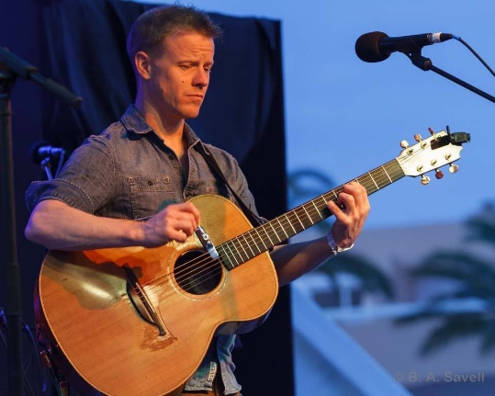 | Benji Kirkpatrick is well known as the rhythmic driver of Bellowhead, with his ‘memorably aggressive’ (MOJO) style. Bellowhead made a huge impact on the UK folk and roots scene until they disbanded in 2016. Currently part of folk rock super group Steeleye Span, Benji previously spent three years in the Seth Lakeman Band having featured on Seth’s successful releases ‘Kitty Jay’ and ‘Freedom Fields’. Benji has also worked with numerous other artists including Oysterband, John Jones, Maddy Prior Thea Gilmore and Joan as Police Woman. He has also released four solo albums and in 2019 released his first album with new Alternative Roots trio, Benji Kirkpatrick & The Excess.
Paul Sartin
Paul Sartin - vocals, fiddle, oboe, cor anglais
Bellowhead, Belshazzar’s Feast, Jon Boden & The Remnant Kings

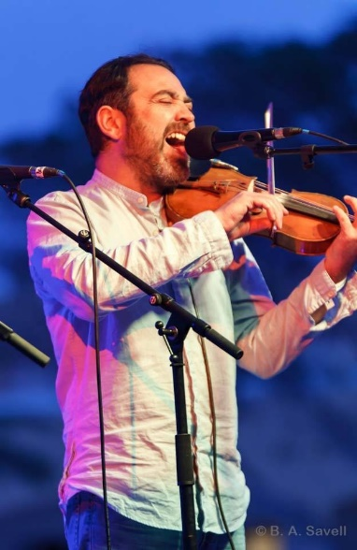 | Paul Sartin is an oboist, singer, traditional violinist, competent pianist and swanee whistle virtuoso. Paul is a prolific and highly-regarded performer, composer, arranger and teacher. He is a founding member of the award- and nomination-winning ensembles – Belshazzar’s Feast and the late Bellowhead, and also appears in Made in the Great War and with Jon Boden and The Remnant Kings. He is Musical Director of the Andover Museum Loft Singers. During 2017 and 2018 he appeared in, as well as directing the music for a new production of Peter Bellamy’s ballad opera The Transports (Guardian *****).

Saul Rose
Saul Rose - vocals, melodeon
Waterson:Carthy, Whapweasel, Eliza Carthy & The Wayward Band

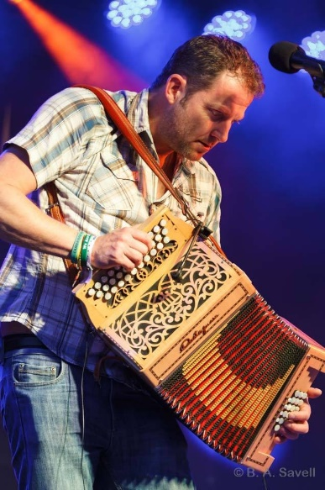 | Saul Rose is a renowned English folk melodeon player and singer. A long-time member of Waterson:Carthy, winning two BBC Radio 2 Folk Awards with ‘Broken Ground’ and forming a duo with Eliza Carthy. Double album ‘Red Rice’ was nominated for the Mercury Music Prize in 1998. Saul played on numerous albums, including Jackie Oates’ ‘Hyperboreans’, Norma Waterson and Eliza Carthy’s album ‘The Gift’ and soundtracks for the films ‘Morris - A Life With Bells On’ and ‘Far From The Madding Crowd’. Nominated for the Musician of The Year award in the 2010 BBC Folk Awards, during 2011 he took the part of Songman in West End play War Horse. Now part of band Whapweasel and duos with James Delarre and with Maclaine Colsten, Saul was also a founder member of Eliza Carthy & The Wayward Band.

REVIEWS & DISCOGRAPHY
‘Cotton Lords; five songs of the Lancashire Cotton Famine’ EP (2019)
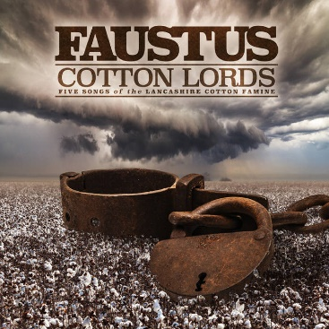 | - ‘With three of the best musicians currently on the folk circuit, this EP comes highly recommended.’ (Shire Folk).  - ‘With exquisite instrumentation and haunting harmonies to the fore, this is the quality we have come to expect from Faustus.’ (Folk Radio)

‘Death & Other Animals’ (2016)
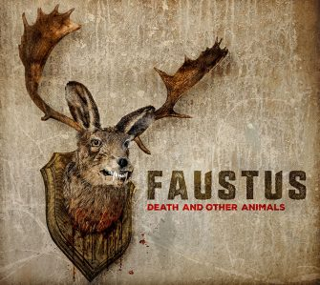 | - ‘The first blokes of folk make a blistering return to save us all from the fay and the wan with their most powerful and ambitious set to date. Death and Other Animals is Faustus running on full steam. If they have made a pact with the devil then it’s surely serving them well.’ (Bright Young Folk)  - ‘Purveyors of instrumental finesse, with the kind of arrangements that don’t just wake up in the morning and yawn themselves into being. Three years on from the great Broken Down Gentlemen, Faustus are at their best here.’ (Songlines)

‘Broken Down Gentlemen’ (2013)
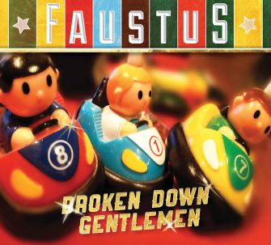 | - ‘A considered album of exceptional class’ (Daily Telegraph*****)  - ‘Frill-free folk music, superbly and tastefully performed...a folk essential’ (Sunday Times ****)  - ‘Captivated by the power of this new album..Broken Down Gentlemen’ has been well worth waiting for’ (Folk Radio)

Faustus (2008)
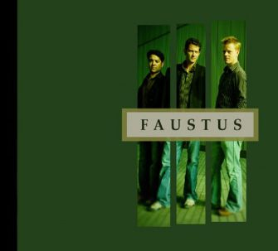 | Their eponymous debut album saw Faustus being nominated as the Best Group in the 2009 BBC Radio 2 Folk Awards.

TECHNICAL SPECIFICATION

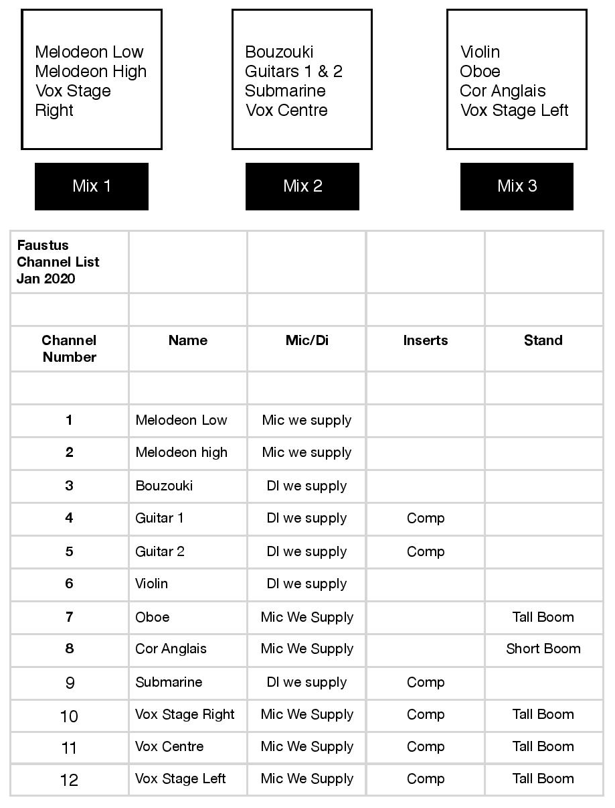
Please supply the following:
- A FOH system in full working order that can deliver a full range sound at 110db evenly across the listening area of the audience. This is to ensure there is enough dynamic range in the system and not for excessive volume.
- 4 x Tall mic stands in full working order
- 1 x Short Boom stand in full working order
- 3 x 4 way power points (1 at each of the 3 monitor positions)
- Lots of xlr to xlr mic lead (at least 30 but more would be safe)
- An analogue multicore to the FOH mix position if possible.

We will supply the mixing desk, 4 x powered stage monitors, all mics and Di boxes required.
To discuss any aspect of the tech spec please contact us.

CATERING RIDER & OTHER REQUIREMENTS

Please provide a private room with fresh water and tea/coffee, plus a hot meal for the band members plus their sound engineer or alternatively buyout of £10 per person (4 people). Plastic-free food and drink containers are preferred if possible please.

Some or all members of the band and their sound engineer may like to stay overnight (hosted or hotel) if the event is a long way from home. This will be discussed as part of the booking agreement.

INTERNET LINKS
Official website www.faustusband.com
www.facebook.com/faustusmusic/
www.instagram.com/faustusfolk/
http://www.twitter.com/faustusmusic/
https://www.youtube.com/channel/UCm36HCDfYjr5wETPh7MpIPQ

CONTACT
Claire Patterson
Booking Agent
+44 (0) 7872 075626
claire.s.patterson@outlook.com
www.goodhonestmusic.com
Good Honest Music is a UK-based folk & roots music booking agency representing: Jackie Oates | Faustus | Belshazzar’s Feast | Benji Kirkpatrick & The Excess | Jon Wilks | Jackie Oates & John Spiers | Paul Sartin (solo) | Benji Kirkpatrick (solo)

